Experiment 11 – Docker Static Website: VS Code code, Dockerfile, terminal image build, running container, and website in Chrome.
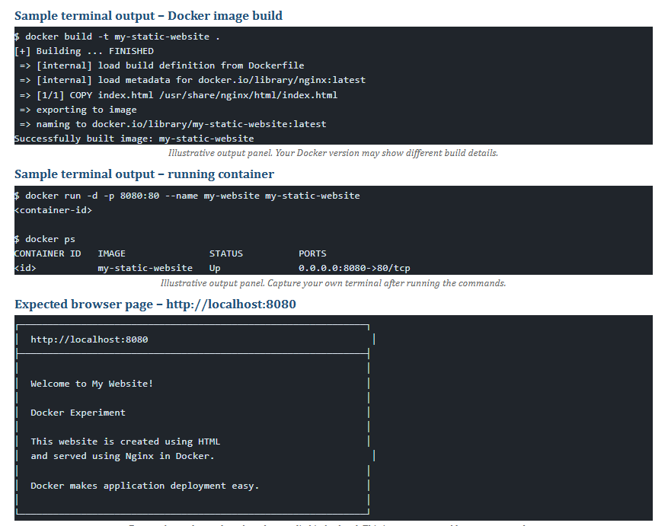

12. Experiment 2 – Flask + Docker + Kubernetes: Flask code, Dockerfile, Docker Hub image, Deployment YAML, Service YAML, running pods, and API output in Chrome.
